Explanation | Screenshot
Emirates Nuclear Energy Corporation
As a supplier, to be part of the ENEC Supplier database, the first step is to submit a request with the ENEC SRM Team.  Use the following link to access the ENEC supplier page: www.enec.gov.ae  (1) Clicking the Suppliers tab selects it. | 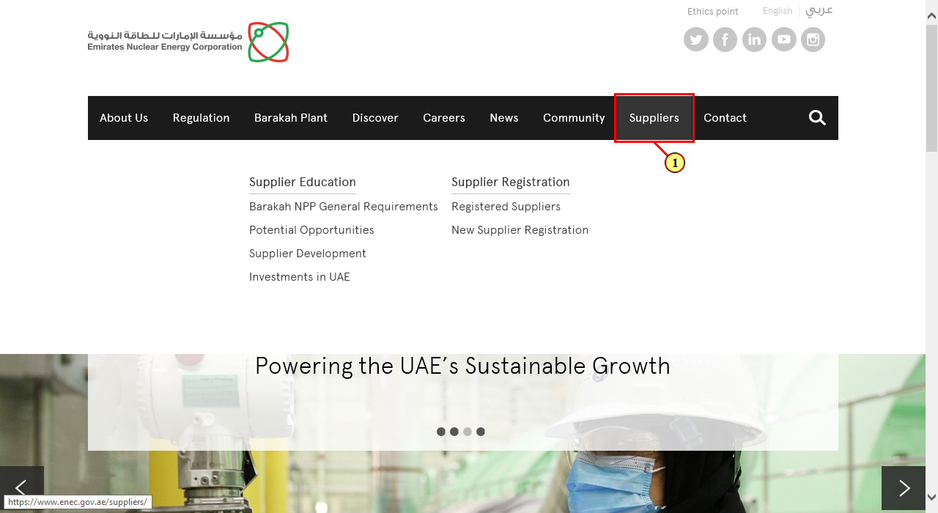
Supplier Information
(2) Clicking in the scroll area displays the desired area. | 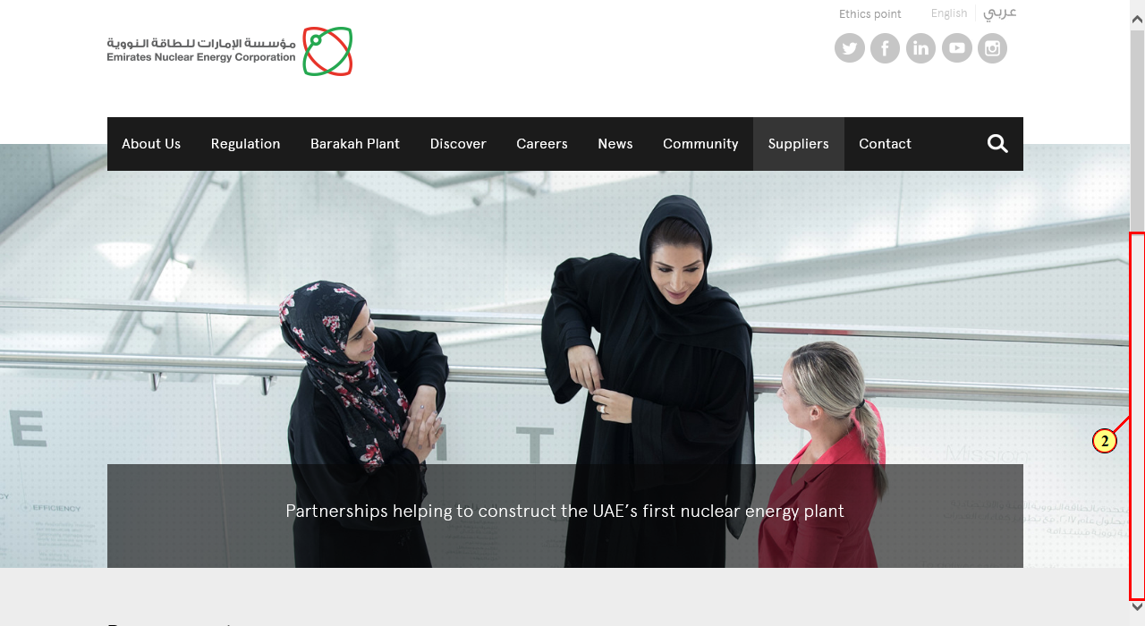
Supplier Information
(3) Click New Supplier Registration . | 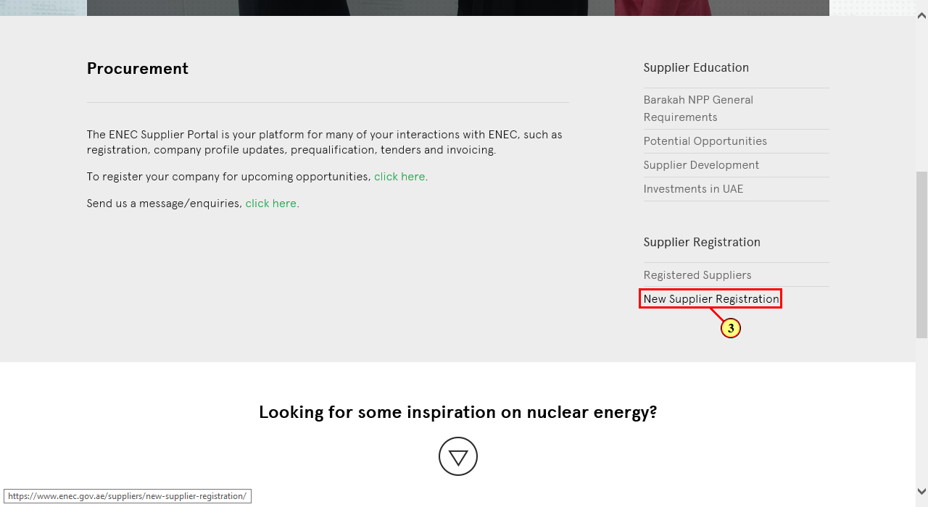
Ariba Spend Management
In the Full Legal Name field, enter the name as per the Trade License acquired by you.  (4) The Full Legal Name field is filled out. | 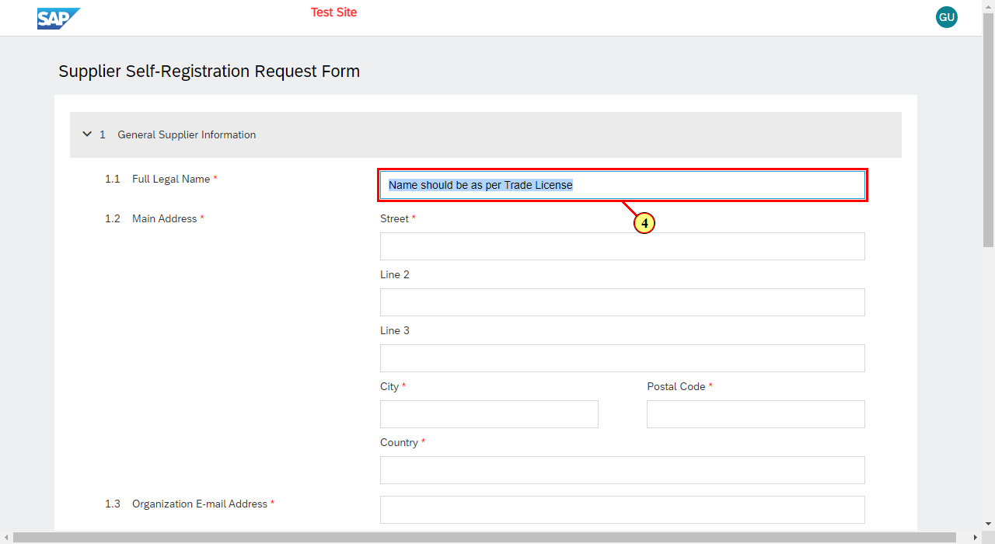
Ariba Spend Management
(5) The Main Address - Street field is filled out. | 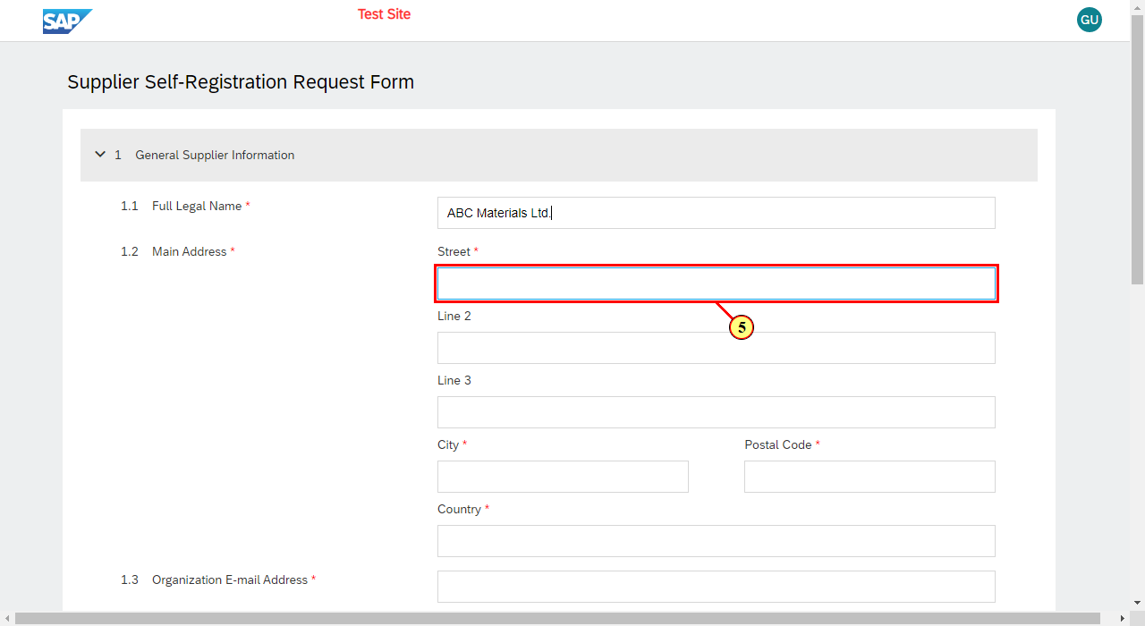
Ariba Spend Management
(6) The City field is filled out. | 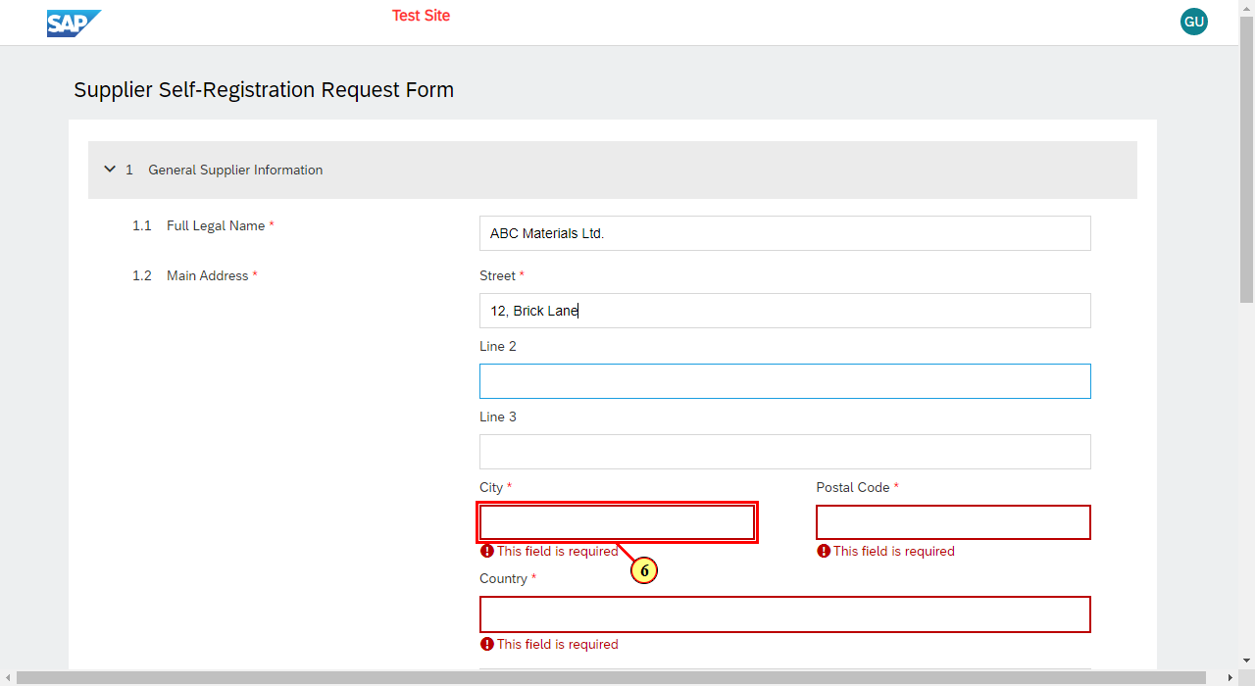
Ariba Spend Management
(7) The Postal Code field is filled out. | 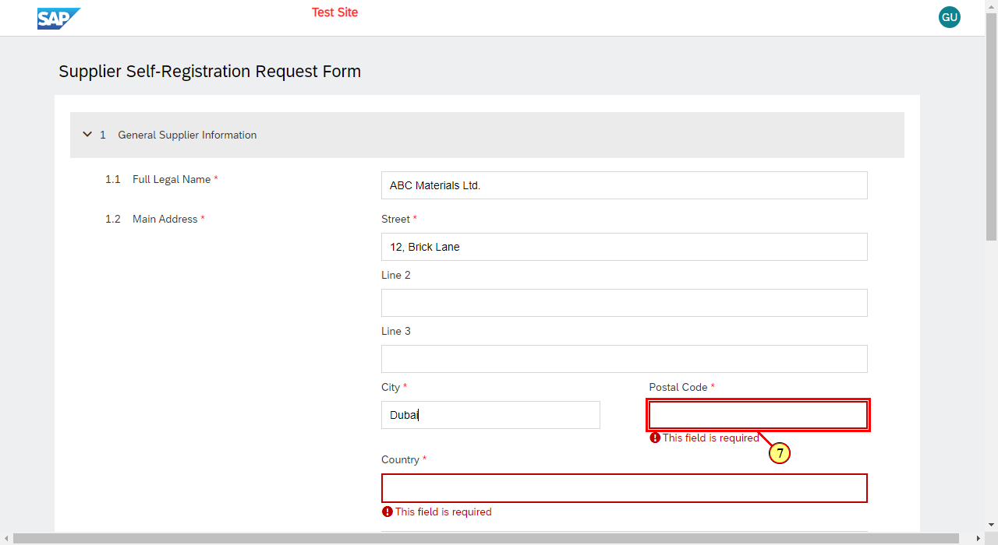
Ariba Spend Management
(8) The Country field is filled out. | 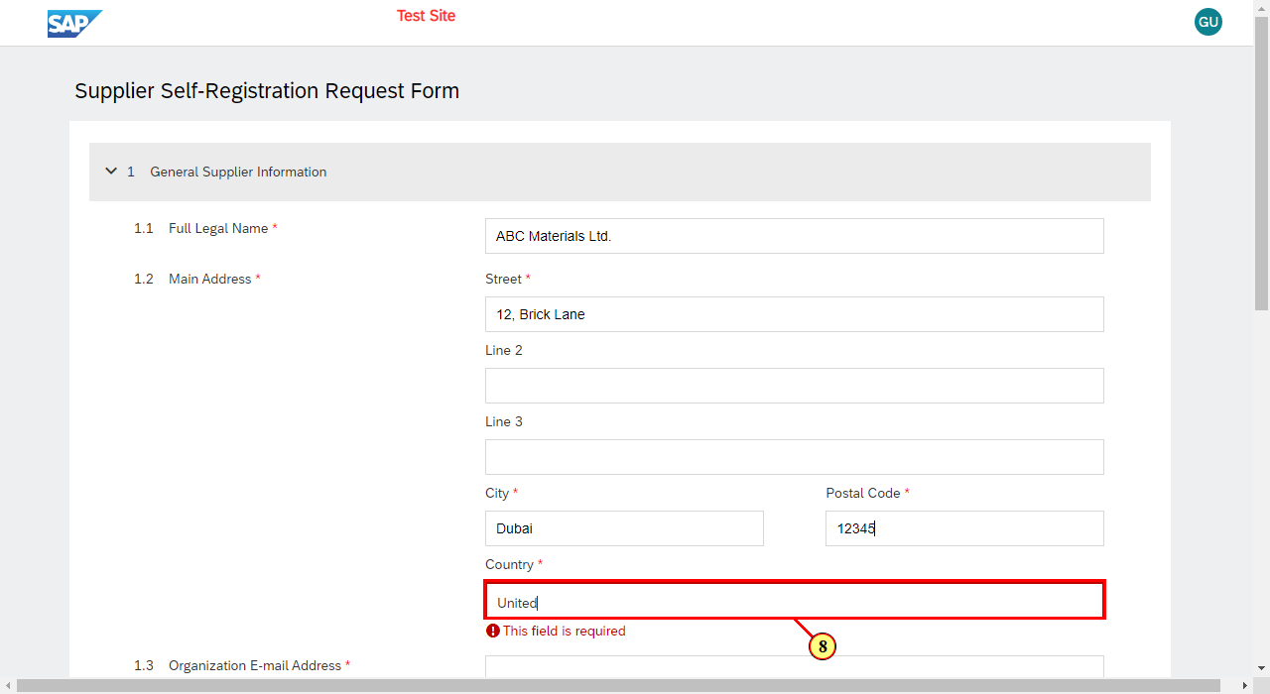
Ariba Spend Management
(9) Clicking the relevant entry selects it. | 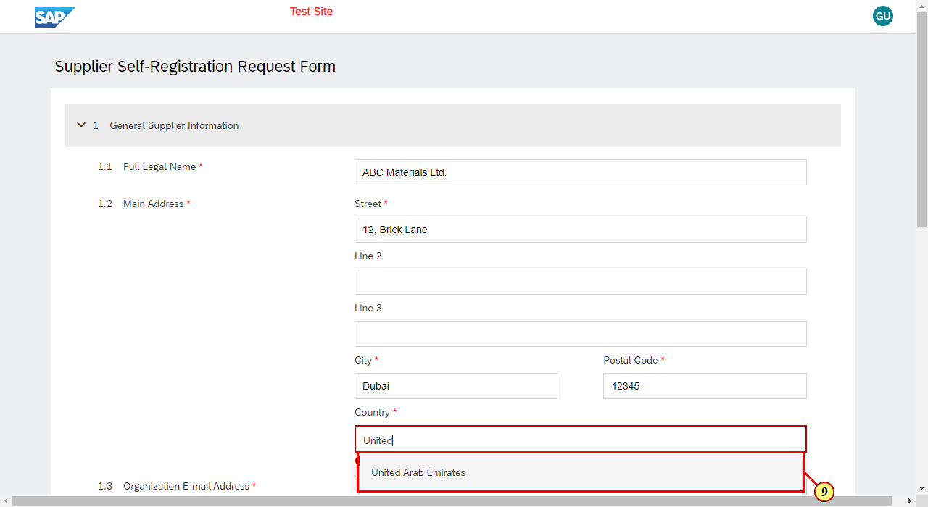
Ariba Spend Management
(10) The Organization E-mail Address field is filled out. | 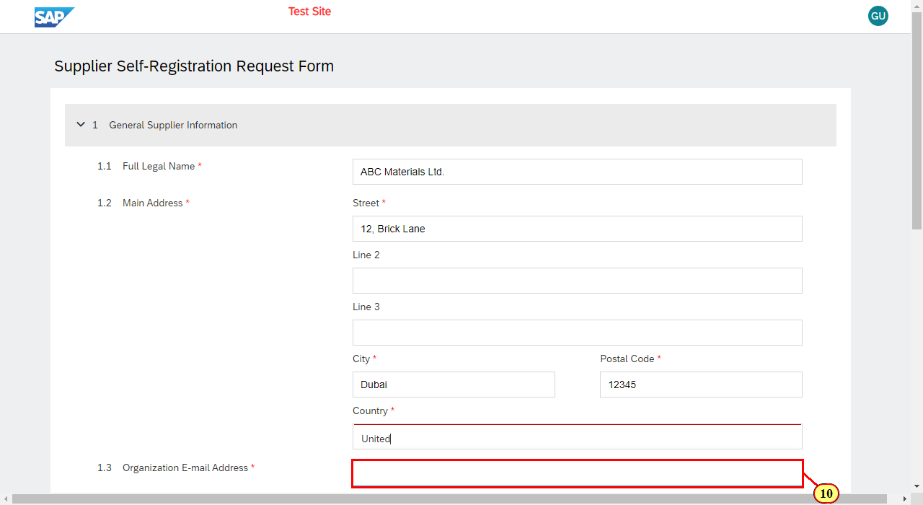
Ariba Spend Management
(11) Clicking in the scroll area makes the desired area appear. | 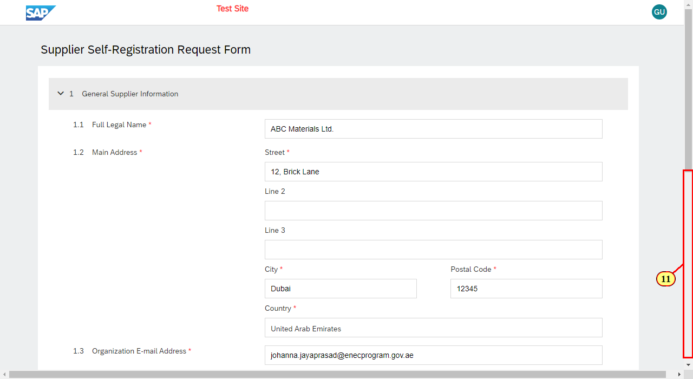
Ariba Spend Management
(12) The License Number field is filled out. | 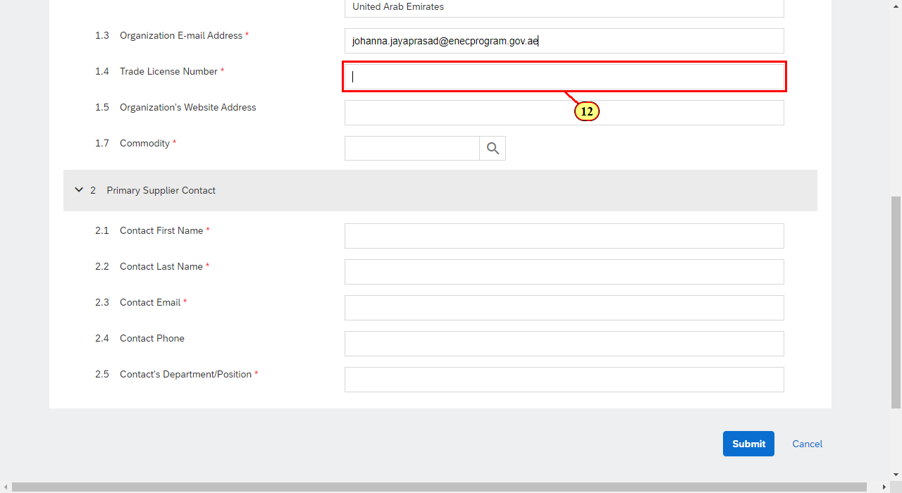
Ariba Spend Management
Enter the commodity name to search for the commodity.  (13) The Commodity field is filled out. | 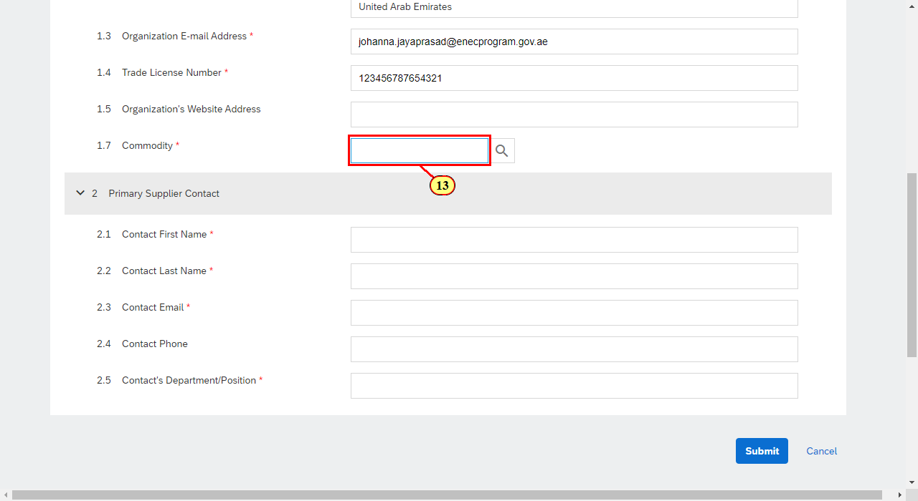
Ariba Spend Management
(14) Select the relevant commodity . | 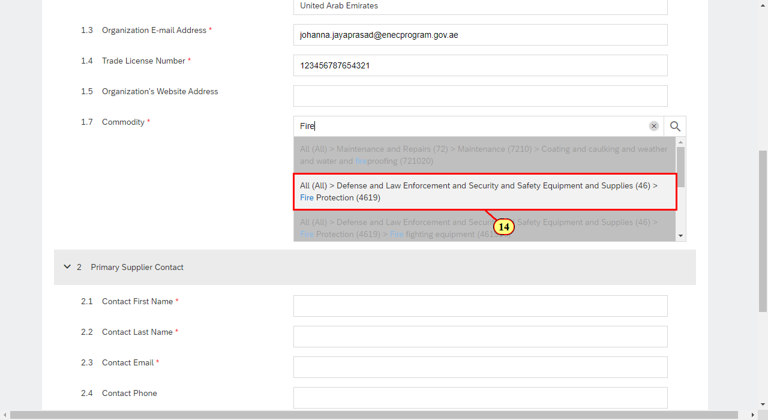
Ariba Spend Management
(15) The Commodity field is filled out. | 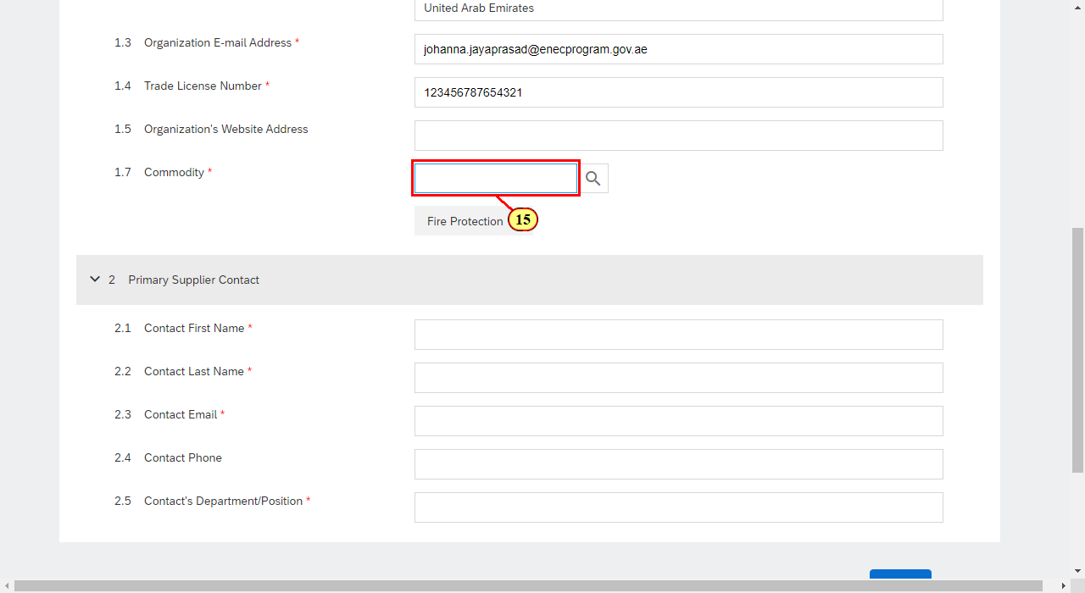
Ariba Spend Management
(16) Select the relevant commodity . | 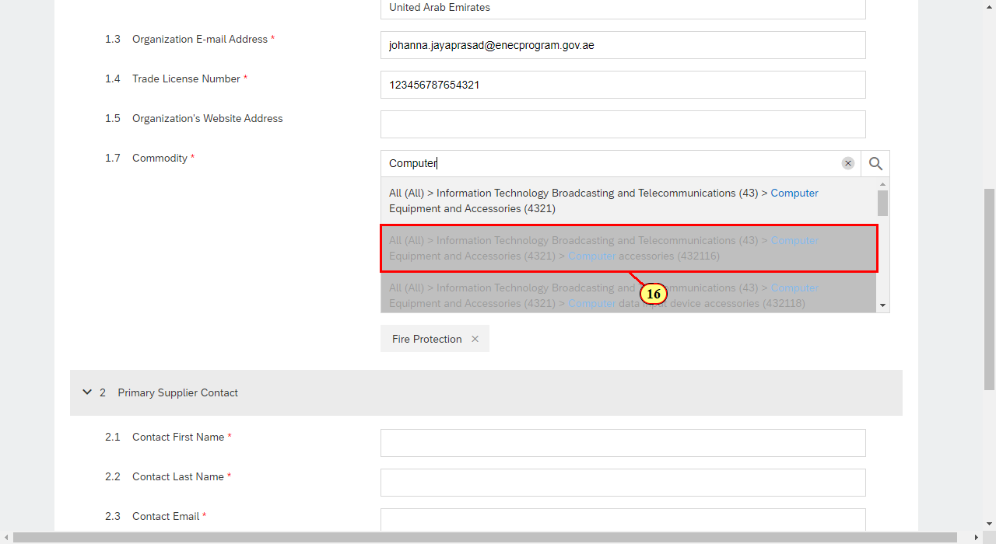
Ariba Spend Management
(17) Clicking in the scroll area makes the desired area appear. | 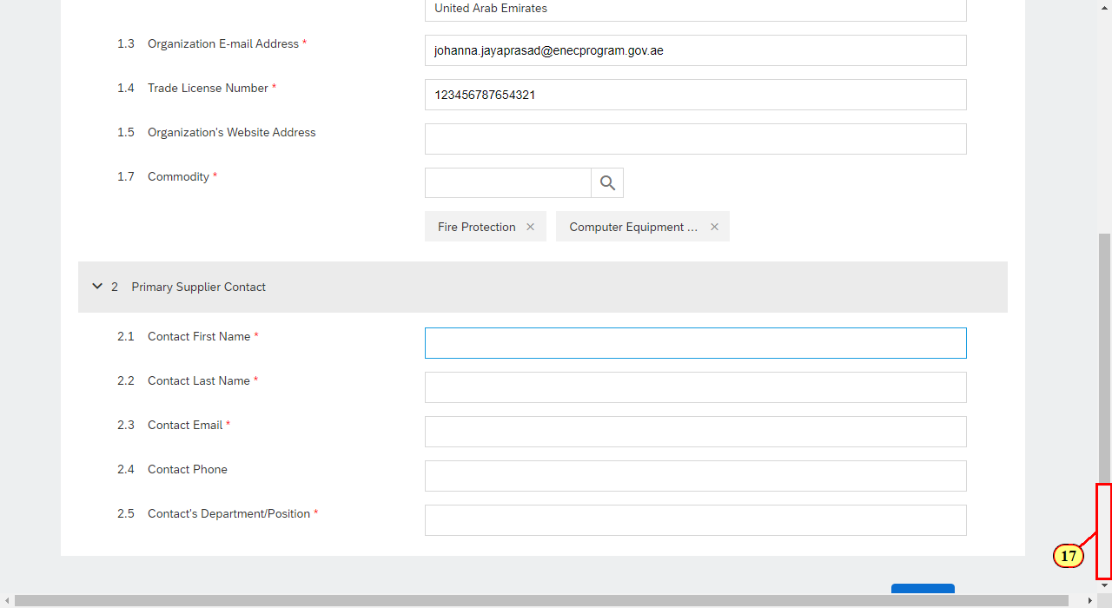
Ariba Spend Management
(18) The Contact First Name field is filled out. | 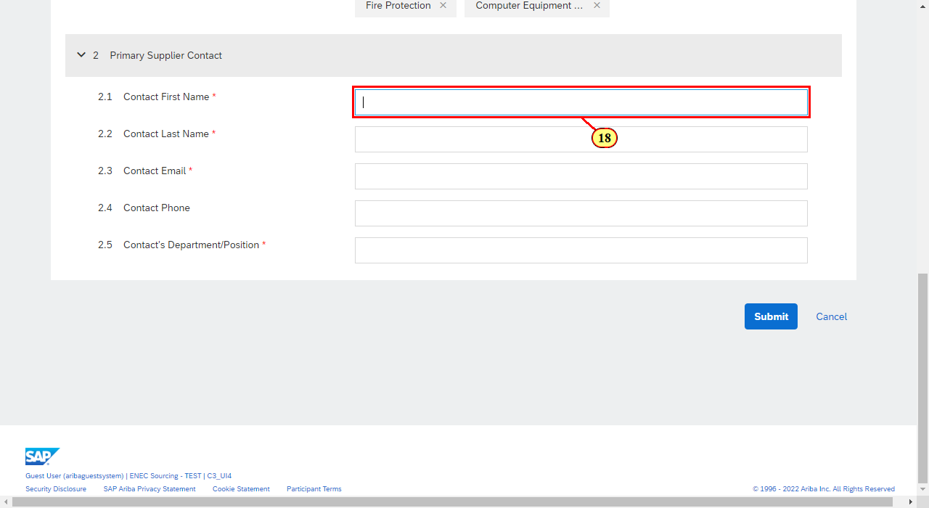
Ariba Spend Management
(19) The Contact Last Name field is filled out. | 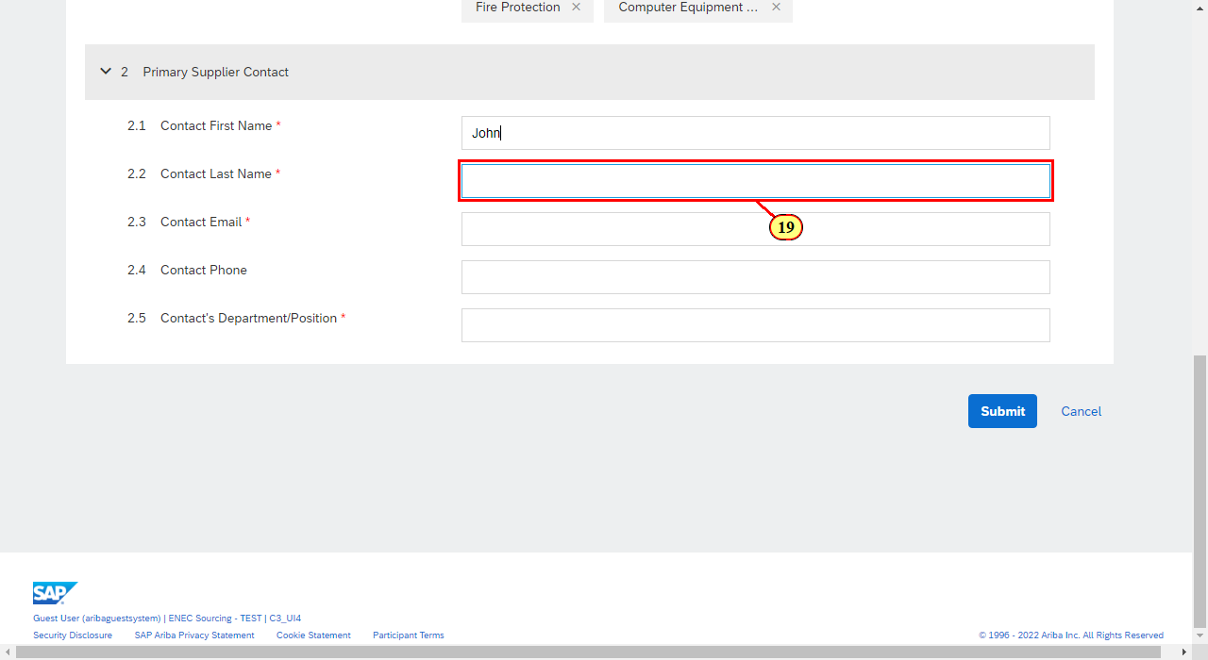
Ariba Spend Management
(20) The Contact Email field is filled out. | 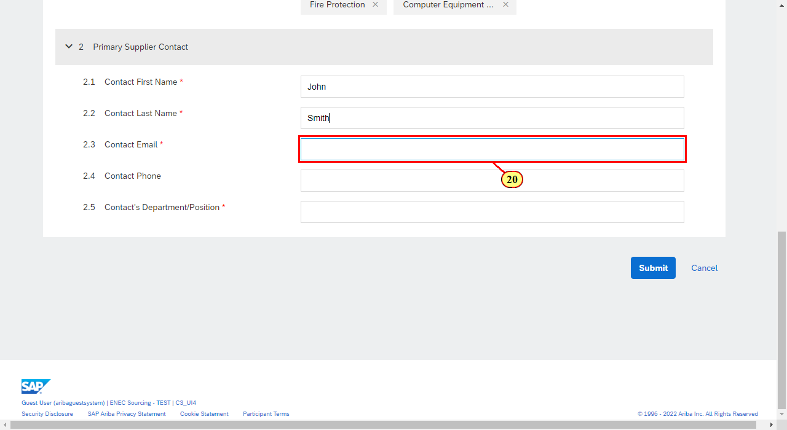
Ariba Spend Management
(21) The Contact's Department/Position field is filled out. | 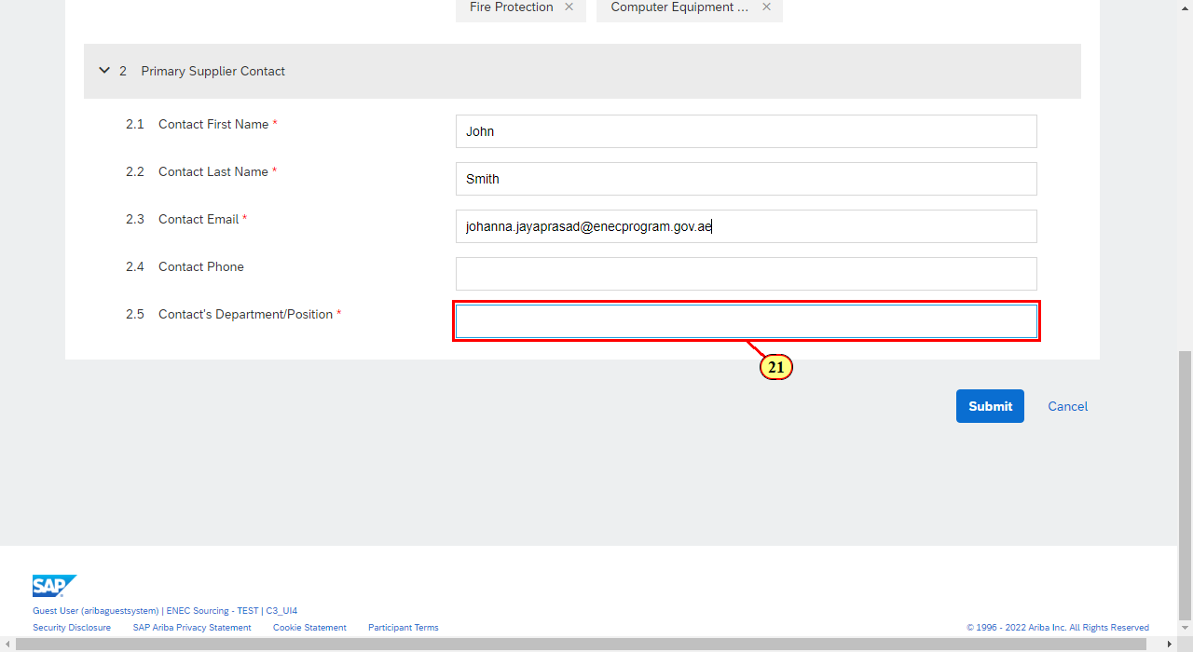
Ariba Spend Management
(22) Click Submit . | 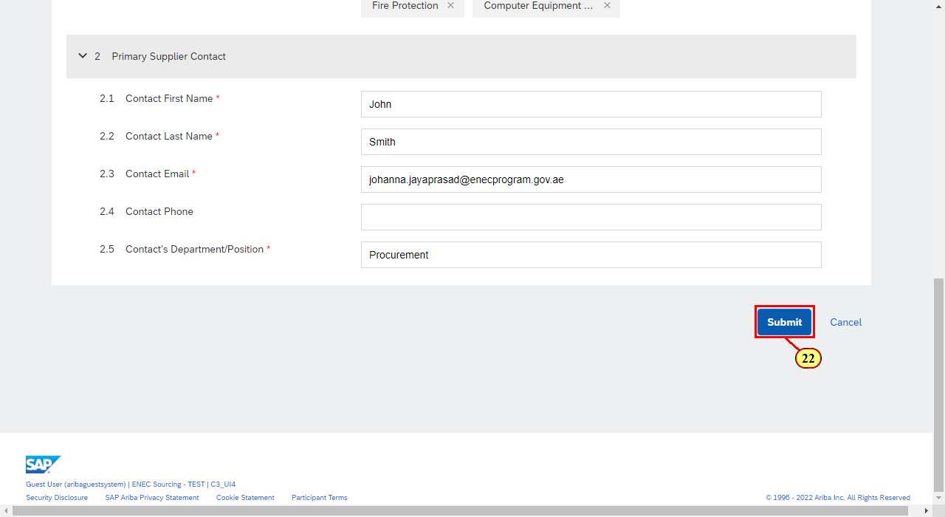
Ariba Spend Management
Your request is submitted with the ENEC SRM Team and you will receive an email confirming the same. | 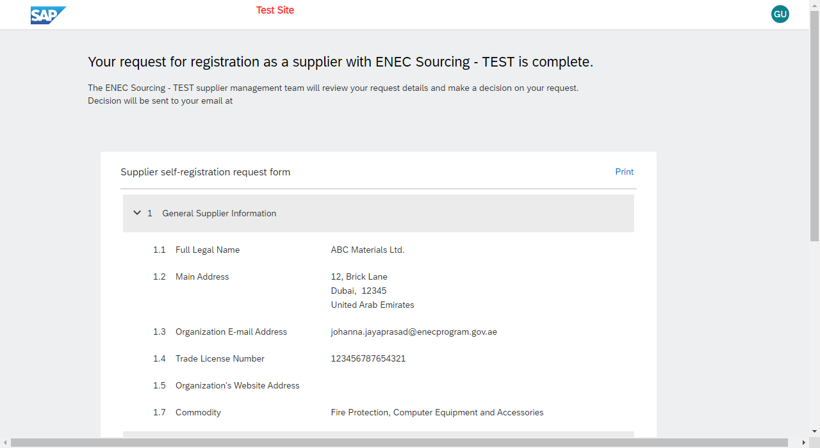
Email
This is the email you will receive confirming your request to ENEC. | 